PRN212 Assignment 02
Building a Hotel Management System with Windows Presentation Foundation (WPF)

1. Introduction
Hotel Management System (HMS) can help you streamline and automate various aspects of managing a hotel. It can help you keep track of room reservations, bills, guest information, and financial transactions. The HMS can also help you manage housekeeping and maintenance tasks, as well as track inventory and purchase orders. Building an HMS can also help you improve customer satisfaction by providing them with a user-friendly interface to book rooms and manage their stays. Here are some key components and functions of a Hotel Management System
- Online Booking and Reservation: The system allows customers to make bookings and reservations online through a user-friendly interface. It provides real-time availability of vehicles, rental rates, and booking confirmations.
- Room Management: Room management in a hotel management system refers to the process of efficiently and effectively managing the rooms and their occupants in a hotel.
- Customer Management: The system maintains a database of customer information, including contact details, identification documents, and room booking history. It enables easy retrieval of customer records, communication, and personalized service.
Imagine you're a developer of a FU Mini Hotel Management System named FUMiniHotelSystem. To implement a part of this system your tasks include:
- Manage customer information.
- Manage room information.
- Manage online/offline booking transaction.
The application has a default account (admin account) whose email is “admin@FUMiniHotelSystem.com” and password is “@@abc123@@” that stored in the appsettings.json.

2. Assignment Objectives
In this assignment, you will:
- Use the Visual Studio.NET to create Windows Presentation Foundation (WPF) and Class Library (.dll) projects.
- Perform CRUD actions using Entity Framework Core.
- Use LINQ to query and sort data.
- Apply passing data in the WPF application.
- Apply 3-Layers architecture to develop the application.
- Apply MVVM (Model-View ViewModel) pattern in the application.
- Apply Repository pattern and Singleton pattern in a project.
- Add CRUD and searching actions to the application.
- Apply to validate data type for all fields.
- Run the project and test the WPF application actions.

3. Database Design
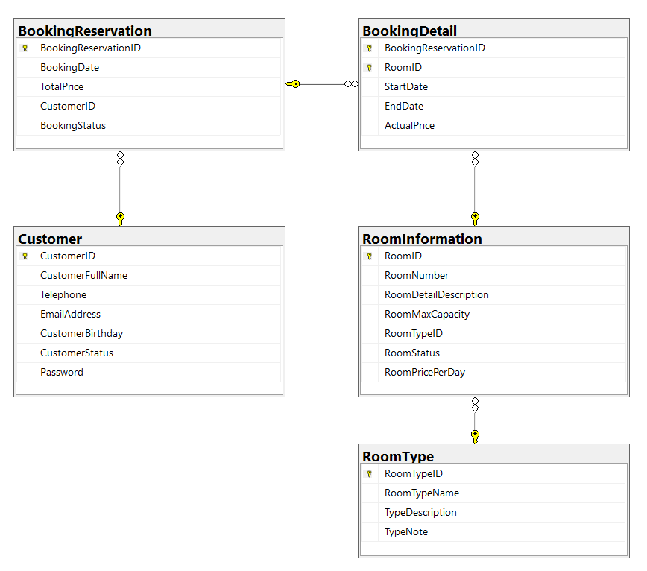
A room will belong to only one room type.
A customer can make booking reservation in this system many times. A booking reservation will have one or many room information. A room information will belong to many booking reservations.

4. Main Functions
- Member (Admin/Customer) authentication by Email and Password.
- If the user is an “Admin” then his/her is allowed
  - Manage customer information.
  - Manage room information. (The delete action will delete room information in the case this information is not belong to any renting transaction. If the room information is already stored in a booking detail, just change the status.)
  - Manage booking reservation (includes booking details)
  - Create a report statistic by the period from StartDate to EndDate, and sort data in descending order.
- If user is a “Customer”, this customer role is allowed to:
  - Manage his/her the profile.
  - View booking reservation history.
- Note that: Customer management, Room management, and Booking reservation management: Read, Create, Update, Delete and Search actions. Creating and Updating actions must be performed by popup dialog. Delete action always combines with confirmation.

5. Note
- You must use Visual Studio 2019 or above (.NET5/.NET6/.NET7/.NET8), MSSQL Server 2012 or above for your development tools.
- To do your program, you must use Windows Presentation Foundation. Note that you are not allow to connect direct to database from WPF, every database connection must be used through Repository and Data Access Objects. The database connection string must get from appsettings.json file.
- Create Solution in Visual Studio named StudentName_ClassCode_A02.sln. Inside your Solution, the Project WPF must be named: StudentNameWPF.
- Create your MS SQL database named FUMiniHotelManagement by running code in script FUMiniHotelManagement.sql.
- Set the default user interface for your project as Login window.

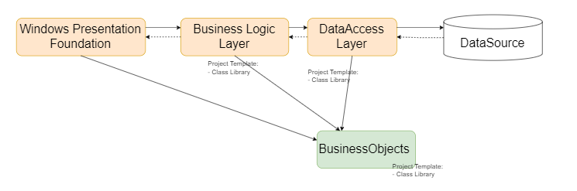
Data Source in this case is the SQL Server Database

